- As expected, UK CPI inflation held steady in August, with higher services inflation offset by a fall in fuel prices. We think base effects will continue to drive some month-to-month volatility in headline inflation in the near term, with a lower September outturn set to be followed by a sharp rise in October, as the new higher energy price cap comes into play.
- The recent decline in oil prices means we now expect the petrol category to drag on headline inflation more significantly in the near-term. However, our annual CPI inflation forecast remains at 2.5% in 2024 and 2025.
CPI inflation remained unchanged at 2.2% in August, which was in line with our forecast. This reflected two main offsetting forces. The fuel category weighed on headline inflation in August, following a 1.5% m/m fall in petrol prices between July and August this year, compared to a 3.7% rise in the same period last year. But this was offset by higher services inflation, due to base effects after an unusually low outturn in August 2023, and a spike in the notoriously volatile air fares component. Elsewhere, RPI inflation edged downwards by 0.1ppt to 3.5%, while RPIX inflation rose to 2.8% from 2.7% in July.
Base effects will continue to play a significant role in shaping month-to-month changes in CPI inflation in the near term. In particular, an unusually high services inflation reading in September 2023 should drag headline inflation below the Bank of England's 2% target in next month's release. But this will prove temporary, with a 10% rise in the Ofgem energy price cap set to drive inflation higher again from October.
The pickup in inflation in the latter part of 2024 will be slightly less severe than we previously forecast because of the recent fall in Brent Crude oil prices. Still, we continue to forecast that CPI inflation will average 2.5% in 2024 and 2025.
Chart 1: We still forecast CPI inflation to average 2.5% this year and next
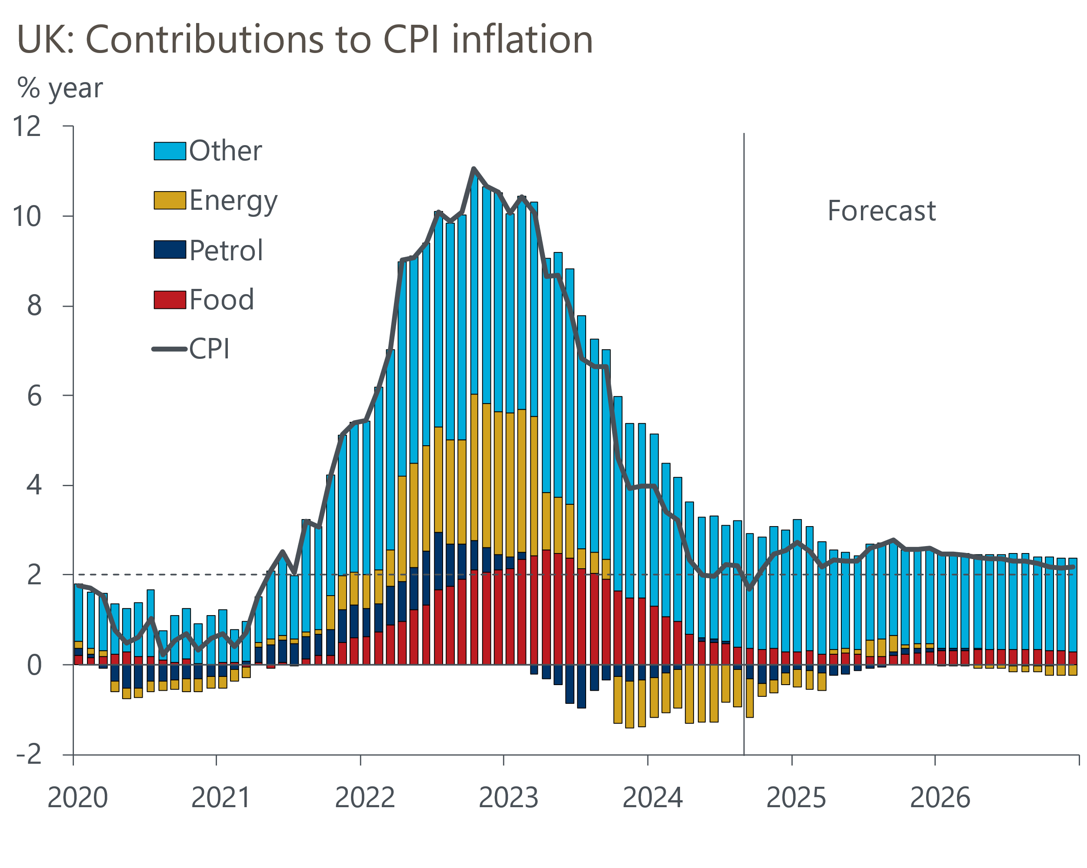
Source: Oxford Economics, Haver Analytics

